Flow of Data Driven Framework

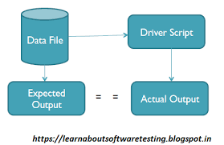

**DATA DRIVEN** TESTING is a test automation **framework** that stores test **data** in a table or spreadsheet format. ... In this **framework**, input values are read from **data** files and are stored into a variable in test scripts. Ddt (**Data Driven** testing) enables building both positive and negative test cases into a single test.

**Why Data Driven Testing?**

Frequently we have multiple data sets which we need to run the same tests on. To create an individual test for each data set is a lengthy and time-consuming process.

Data Driven Testing framework resolves this problem by keeping the data separate from Functional tests. The same test script can execute for different combinations of input test data and generate test results.

**Example:**

For example, we want to test the login system with multiple input fields with 1000 different data sets.

To test this, you can take following different approaches:

**Approach 1)** Create 1000 scripts one for each dataset and runs each test separately one by one.

**Approach 2)** Manually change the value in the test script and run it several times.

**Approach 3)** Import the data from the excel sheet. Fetch test data from excel rows one by one and execute the script.

In the given three scenarios first two are laborious and time-consuming. Therefore, it is ideal to follow the third approach.

Thus, the third approach is nothing but a Data-Driven framework.